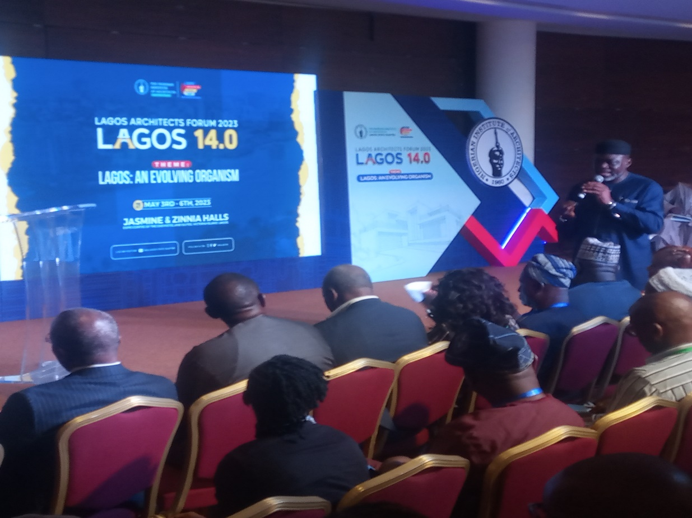

2023 Lagos Architects Forum 14.0

LAGOS: AN EVOLVING ORGANISM

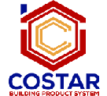

LAGOS ARCHITECTS FORUM is the annual flagship event for Architects who live and work in Lagos, with active participation of Construction Industry Professionals and Service Providers. The event which was hosted on Wednesday 3rd May 2023 to Saturday 6th May 2023 at the Jasmine and Zinnia Halls, Expo Centre of the Eko Hotel & Suites, Victoria Island, Lagos.

The four day event which was Tagged LAF14.0, has the theme “LAGOS: AN EVOLVING ORGANISM”. The events was purposely hosted to bring together like minds and experienced professionals in the industry to discuss trending issues around Lagos and seek ways to improve the expertise of the institute.

Costar Chem Nigeria was there in full capacity as an event partner to educate the guest participants on her construction chemicals; the various categories and benefits.
The guest were fascinated by the alluring product display and presentation of Costar Chem’s products at the exhibition stand.

BRAND ENGAGEMENT - Look & Feel
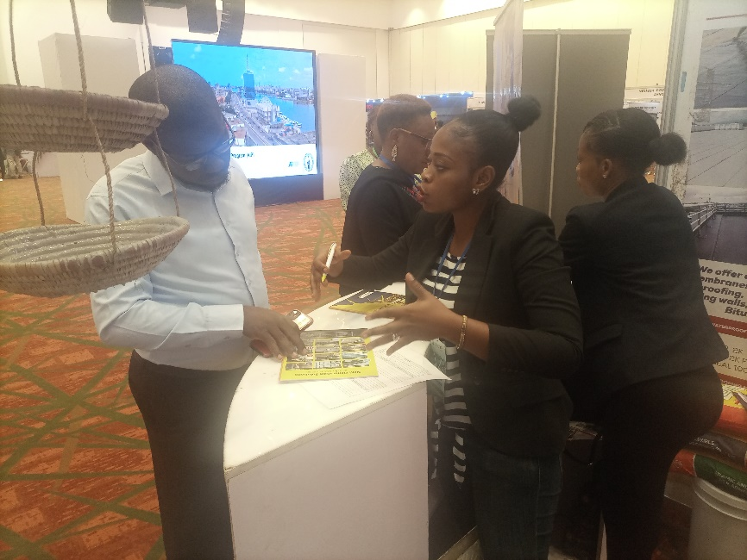
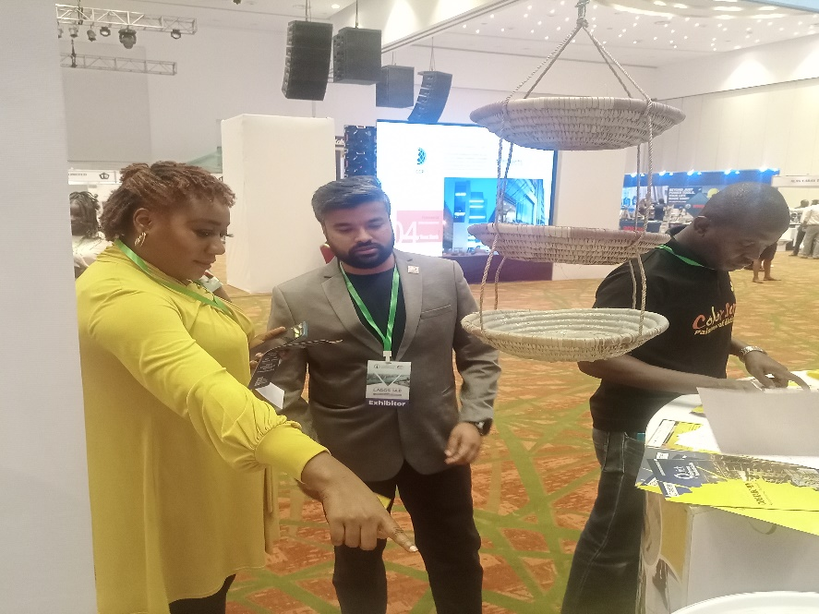
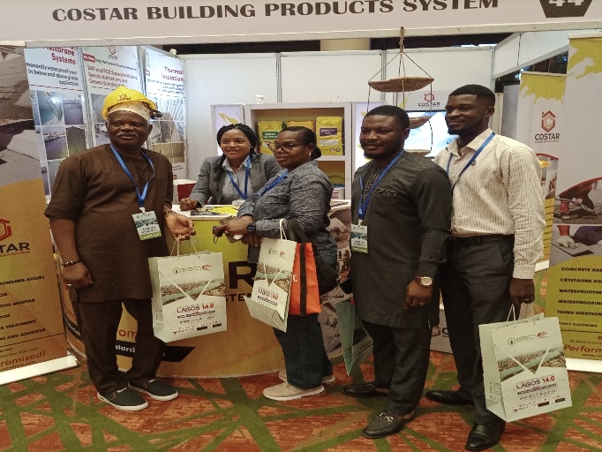
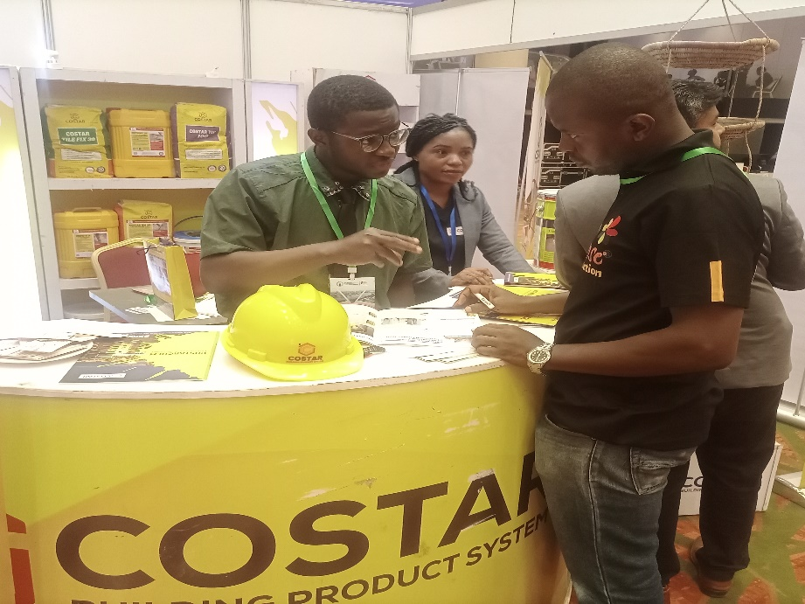
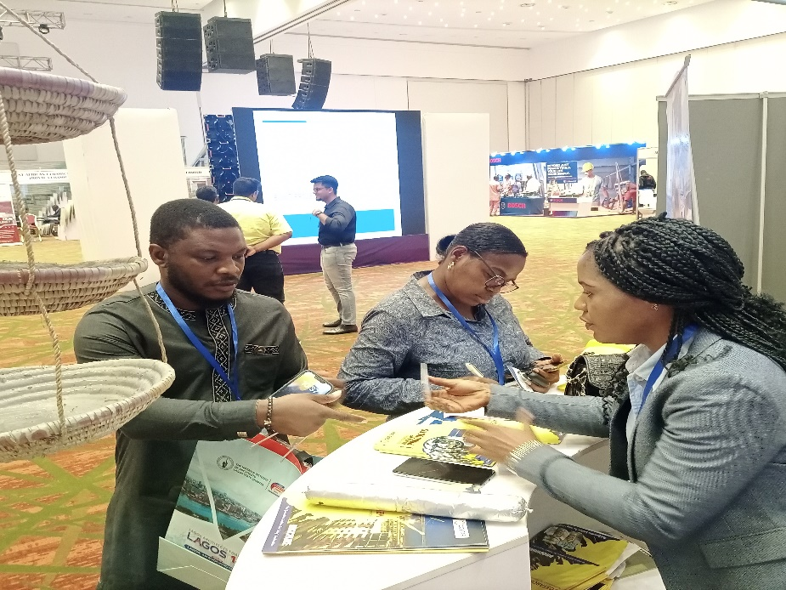
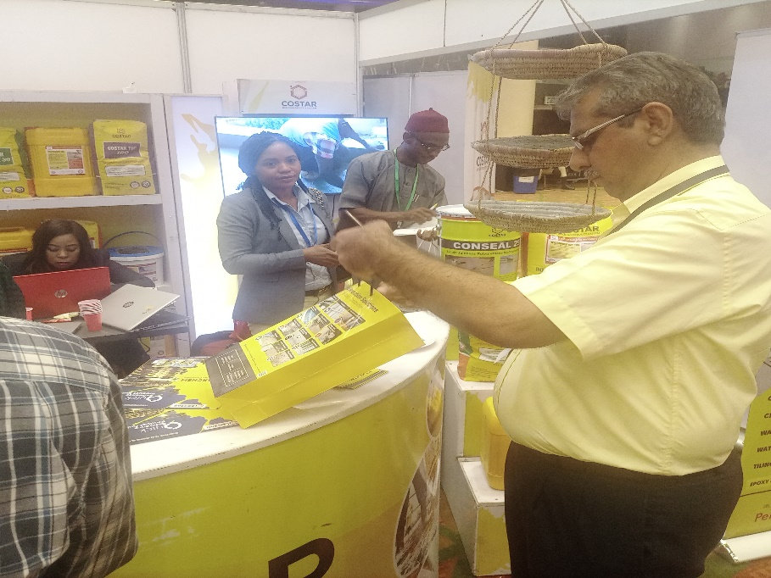

PRESENTATION AND ENGAGEMENT - Look & Feel

